Test Summary Report

CONTENTS

1. Purpose…………………………………………………………………………………………………………….2
2. Application overview…………………………………………………………………………………………2
3. Testing scope…………………………………………………………………………………………………….2
4. Individual Module Testing………………………………………………………………………………….3

**Test performed by**: Kriti Chapagain, Samar Pratap Singh

**Test performed for:** Train Ticket Reservation System

# 

# 1. Purpose

This document explains the various activities performed as part of Testing of ‘Train Ticket Reservation system’ application.

# 2. Application Overview

‘Train Ticket Reservation system’ is a web based train ticket booking application. Tickets for various buses can be booked using the online facilities. Real time passenger information is received from a ‘Central repository system’, which will be referred before booking is confirmed. There are several modules like Registration, Booking, Payment which are integrated to fulfill the purpose.

# 3. Testing Scope

*This section explains about the functions/modules in scope & out of scope for testing; Any items which are not tested due to any constraints/dependencies/restrictions.*

### **In Scope**

Functional Testing for the following modules are in Scope of Testing

* Registration
* Login
* Booking
* Payment

### **Items not tested**

Verification of connectivity with the third party system ‘Central repository system’ was not tested, as the connectivity could not be established due to some technical limitations. This can be verified during UAT (User Acceptance Testing) where the connectivity is available or can be established.

**INDIVIDUAL MODULE TESTING**

|  |  |  |  |  |  |
| --- | --- | --- | --- | --- | --- |
| **Module**  **Name** | **Description** | **Valid Test cases &**  **Invalid Test cases** | **Expected**  **Result** | **Actual**  **Result** | **Status**  **Pass/fail**  **(If ER matched with AR)** |
| **Registration** | In this module , user needs fill in his details in order to get registered to the portal. | **Invalid Test case:**  If the user is already registered, they can’t register again with same credentials**.**  **Valid Test case:**  If the new user registers for the portal, the will successfully create a new account. | The user is not able to register with same E-mail  address.  The user gets logged in to the portal. | The user is not able to register with same E-mail address.  The user gets logged in to the portal. | **PASS**  **PASS** |
| **Login** | In this module, user gets logged in to the portal with the registered credentials. | **Invalid test case:**  If any of the credentials is wrong, they won’t be able to log in to the portal.  **Valid test case:**  If the credentials are correct, the user will be able to log in to the portal**.** | The user is not able to login to the portal.  The user is able to login the portal. | The user is not able to login to the portal.  The user is able to login to the portal. | **PASS**  **PASS** |
| **Booking** | In this module,  User gets to:  1. Select destination  2. Train  3. Date  4. Time  5. No. of tickets | **Test case 01:**  **Test case 02:**  **Test case 03:**  **Test case 04:**  **Test case 05:** | User is able to select the destination.  User can select train of their preference.  Date according to their preference.  Flexible time  Can select required quantity of tickets. | User is able to select the destination.  User can select train of their preference.  Date according to their preference.  Flexible time  Can select required quantity of tickets. | **PASS**  **PASS**  **PASS**  **PASS**  **PASS** |
| **My Reservation** | In this module, user can view their bookings and cancel at any time. | ______________ | user can view their bookings and cancel at any time. | user can view their bookings and cancel at any time. | **PASS** |
| **Payment** | Two options will be provided to the user for payment. | This module should allow user to make payment via credit card or Phone number. | Users are able to complete the payment successfully through any of the mode. | Users are able to complete the payment successfully through any of the mode. | **PASS** |

**LIVE TESTING:**

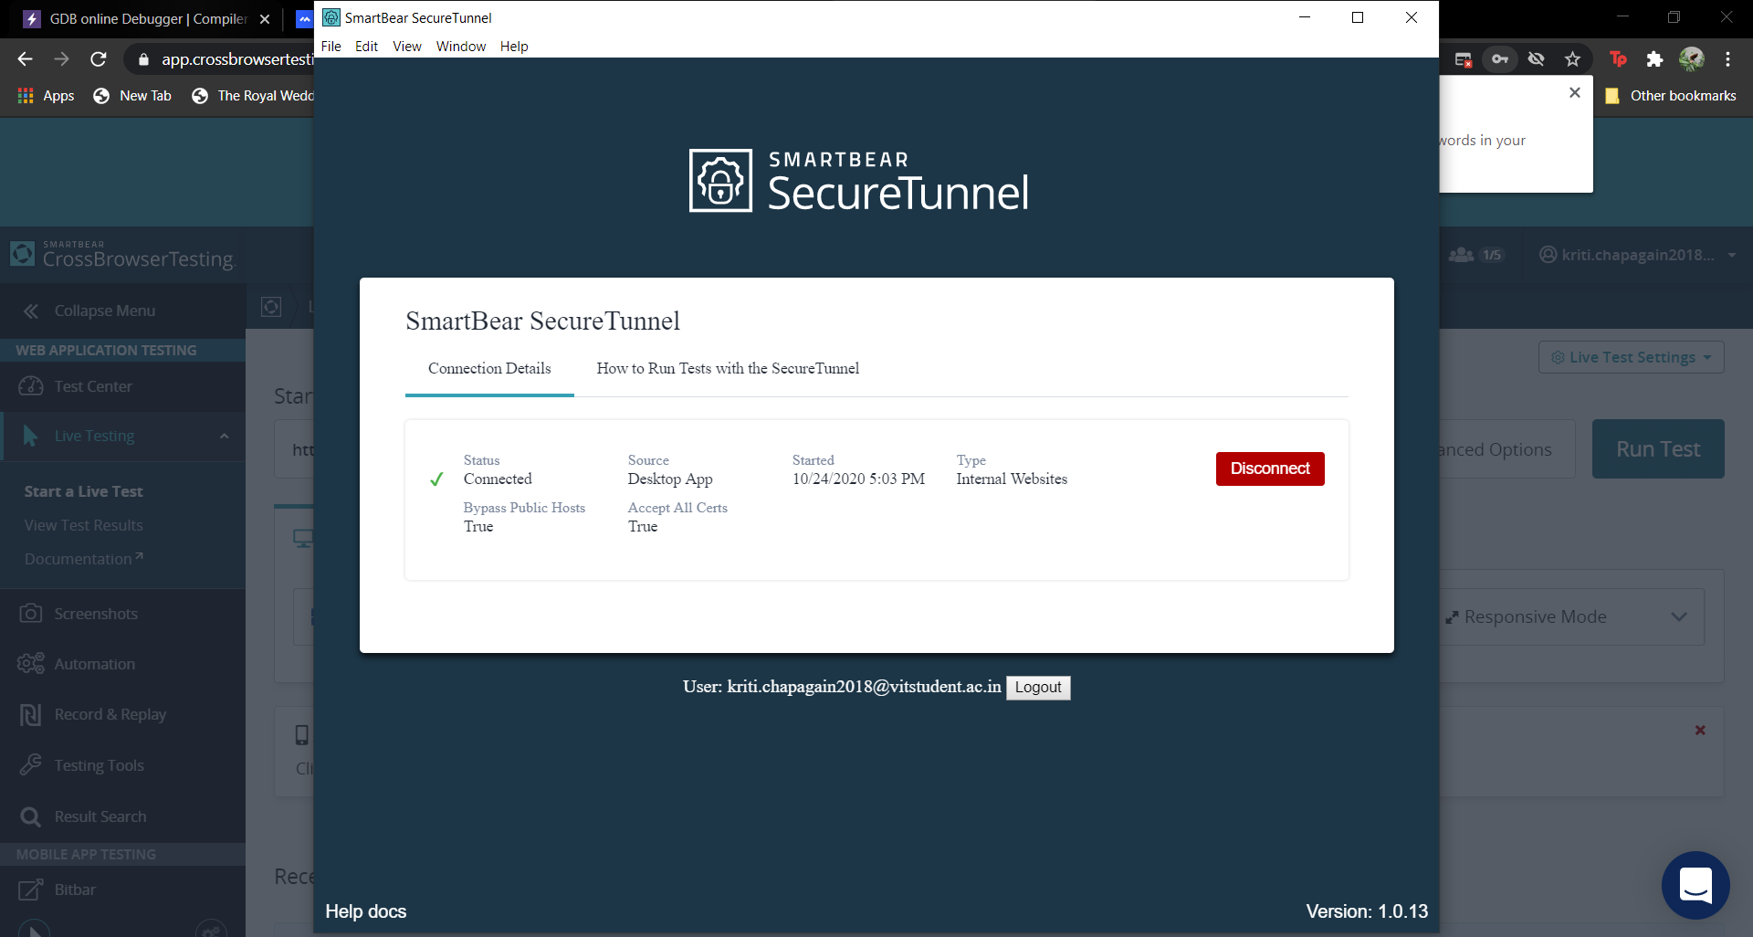

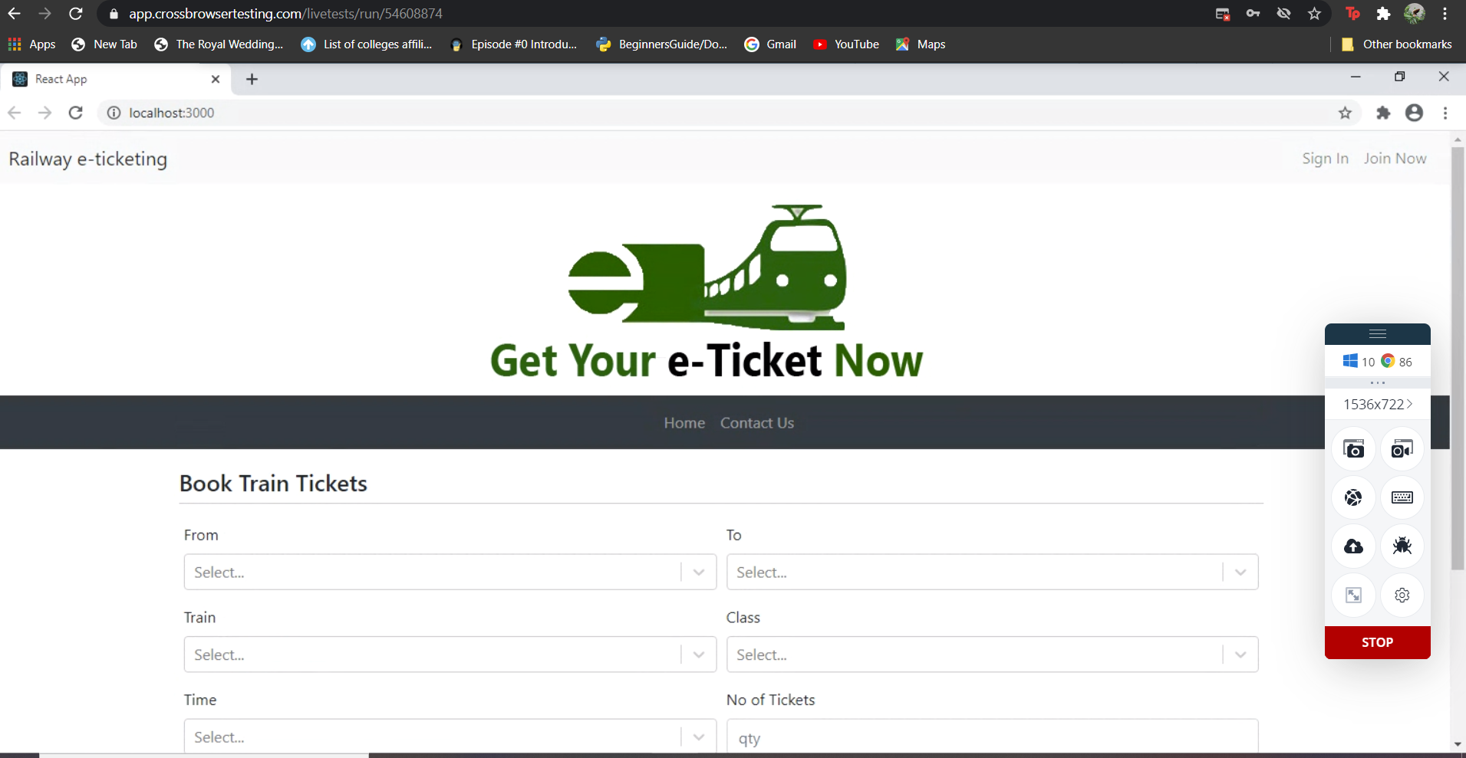

**CONCLUSION:**

In sum up, The overall modules work as per expected and the user Inteface is quite simple and easy to use.